Hello App Program
import 'package:flutter/material.dart';
void main() {
runApp(const MyApp());
}
class MyApp extends StatelessWidget {
const MyApp({super.key});
@override
Widget build(BuildContext context) {
return MaterialApp(
title: 'Hello World App',
home: Scaffold(
backgroundColor: Colors.lightBlue[50], // Light blue background
appBar: AppBar(
title: Text('Hello Flutter'),
backgroundColor: Colors.lightGreen, // AppBar color
),
body: Center(
child: Text(
'Hello, Flutter App!',
style: TextStyle(
fontSize: 45,
fontWeight: FontWeight.bold,
color: Colors.deepOrange, // Text color
),
),
),
),
);
}
}

Output:
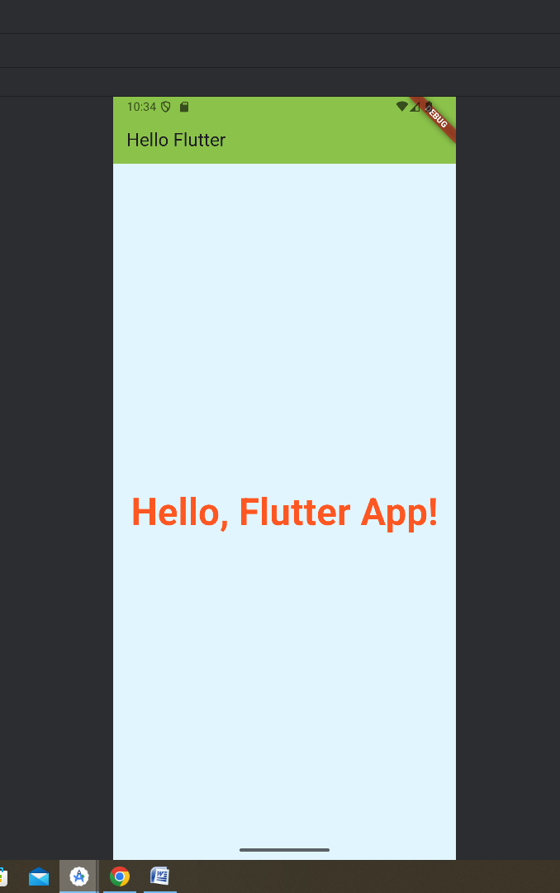

Counter App Program
import 'package:flutter/material.dart';
void main() {
runApp(const MyApp());
}
class MyApp extends StatefulWidget {
const MyApp({super.key});

@override
State<MyApp> createState() => _MyAppState();
}

class _MyAppState extends State<MyApp> {
int counter=0;
@override
Widget build(BuildContext context) {
return MaterialApp(
home: Scaffold(
appBar: AppBar(title: Text("Flutter App",),backgroundColor: Colors.blue,centerTitle: true,),
body: Center(child: Column(mainAxisAlignment: MainAxisAlignment.center,children: [Text('You have pushed the button this many times:',style: TextStyle(fontSize: 18),),
Text("$counter",
style: TextStyle(fontSize: 25,fontWeight: FontWeight.bold,color: Colors.red),)],),),
floatingActionButton: FloatingActionButton(onPressed: (){
setState(() {
counter+=1;
});

},child: Icon(Icons.add),),
),
);
}
}
Output:
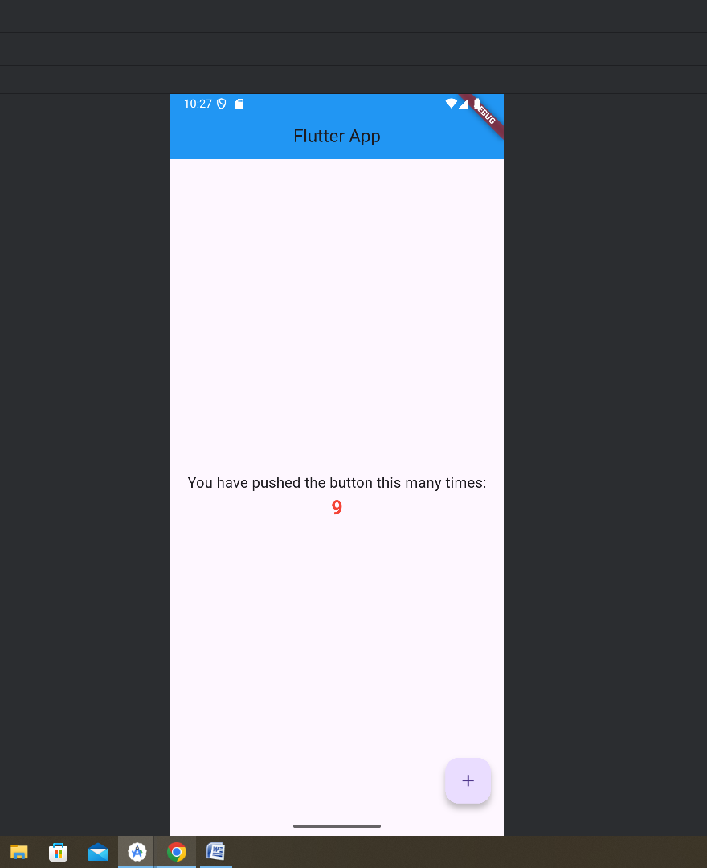

Simple Basic Dart Programs Include variables, functions, conditionals, loops, classes, and data types — all printed in a Text() widget in Flutter.

import 'package:flutter/material.dart';
void main() {
runApp(const MyApp());
}

class Person {
String name;
int age;
Person(this.name, this.age);
String greet() {
return 'Hello, my name is $name and I am $age years old.';
}
}
int square(int x) => x * x;

class MyApp extends StatelessWidget {
const MyApp({super.key});
@override
Widget build(BuildContext context) {
return const MaterialApp(
debugShowCheckedModeBanner: false,
home: MyHomePage(),
);
}
}

// ✅ Use StatefulWidget here
class MyHomePage extends StatefulWidget {
const MyHomePage({super.key});
@override
State<MyHomePage> createState() => _MyHomePageState();
}

class _MyHomePageState extends State<MyHomePage> {
String title = 'Dart Basics Demo';
int number = 5;
double pi = 3.14159;
bool isLearning = true;
List<String> fruits = ['Apple', 'Banana', 'Mango'];

@override
Widget build(BuildContext context) {
String learningStatus = isLearning ? 'You are learning Dart!' : 'Take a break.';
Person person = Person('Alice', 25);
String greeting = person.greet();

return Scaffold(
backgroundColor: Colors.grey[100],
appBar: AppBar(
title: Text(title),
backgroundColor: Colors.teal,
),
body: SingleChildScrollView(
padding: const EdgeInsets.all(16),
child: Column(
crossAxisAlignment: CrossAxisAlignment.stretch,
children: [
infoCard('Square of $number', '${square(number)}', Icons.calculate),
infoCard('Value of Pi', '$pi', Icons.circle),
infoCard('Status', learningStatus, Icons.info),
infoCard('Person', greeting, Icons.person),
fruitCard('Fruits', fruits),
],
),
),
);
}

Widget infoCard(String title, String value, IconData icon) {
return Card(
margin: const EdgeInsets.symmetric(vertical: 8),
elevation: 4,
child: ListTile(
leading: Icon(icon, color: Colors.teal),
title: Text(
title,
style: const TextStyle(fontWeight: FontWeight.bold),
),
subtitle: Text(value),
),
);
}

Widget fruitCard(String title, List<String> items) {
return Card(
margin: const EdgeInsets.symmetric(vertical: 8),
elevation: 4,
child: ExpansionTile(
leading: const Icon(Icons.local_grocery_store, color: Colors.teal),
title: Text(
title,
style: const TextStyle(fontWeight: FontWeight.bold),
),
children: items
.map((item) => ListTile(
title: Text(item),
))
.toList(),
),
);
}
}
Output:
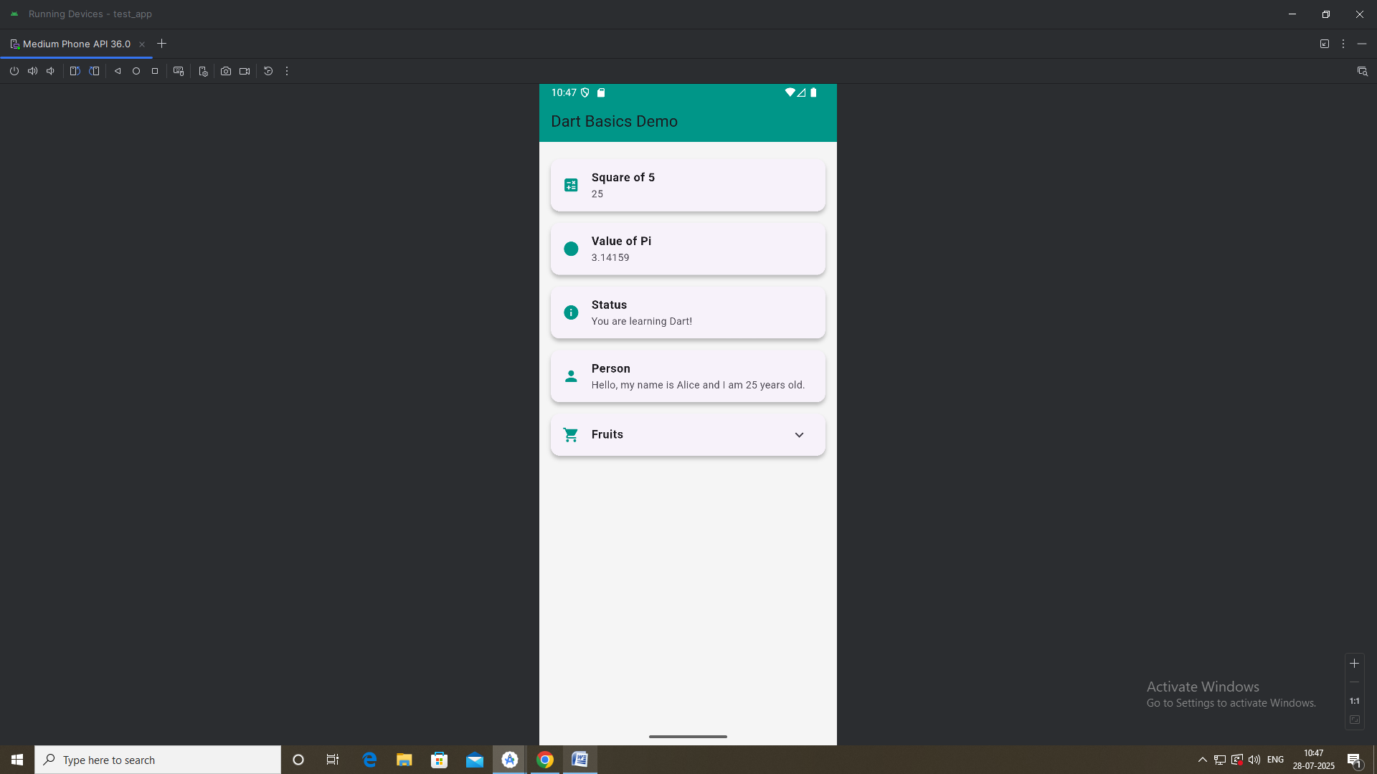
2. a. Explore various Flutter widgets (Text, Image, Container, etc.).
import 'package:flutter/material.dart';

void main() {
runApp(const MyApp());
}

class MyApp extends StatelessWidget {
const MyApp({super.key});

@override
Widget build(BuildContext context) {
return MaterialApp(
title: 'Student Profile Card',
home: Scaffold(
backgroundColor: Colors.lightBlue[50],
appBar: AppBar(
title: const Text('Profile Card'),
backgroundColor: Colors.blueAccent,
),
body: Center(
child: Column(
mainAxisAlignment: MainAxisAlignment.center,
children: [
// Profile picture
const CircleAvatar(
radius: 60,
backgroundImage: AssetImage('images/profile.png'),
),
const SizedBox(height: 20),

// Name
const Text(
'Flutter App',
style: TextStyle(
fontSize: 28,
fontWeight: FontWeight.bold,
color: Colors.blueAccent,
),
),

// Profession
const Text(
'Flutter Beginner',
style: TextStyle(
fontSize: 20,
color: Colors.black54,
),
),

const SizedBox(height: 20),

// Contact Card
Container(
margin: const EdgeInsets.symmetric(horizontal: 40),
padding: const EdgeInsets.all(12),
decoration: BoxDecoration(
color: Colors.white,
borderRadius: BorderRadius.circular(12),
boxShadow: const [
BoxShadow(color: Colors.grey, blurRadius: 4),
],
),
child: Row(
children: const [
Icon(Icons.phone, color: Colors.green),
SizedBox(width: 10),
Text(
'+91 9887766554',
style: TextStyle(fontSize: 18),
),
],
),
),

const SizedBox(height: 12),

Container(
margin: const EdgeInsets.symmetric(horizontal: 40),
padding: const EdgeInsets.all(12),
decoration: BoxDecoration(
color: Colors.white,
borderRadius: BorderRadius.circular(12),
boxShadow: const [
BoxShadow(color: Colors.grey, blurRadius: 4),
],
),
child: Row(
children: const [
Icon(Icons.email, color: Colors.redAccent),
SizedBox(width: 10),
Text(
'vit@example.com',
style: TextStyle(fontSize: 18),
),
],
),
),
],
),
),
),
);
}
}

Output:
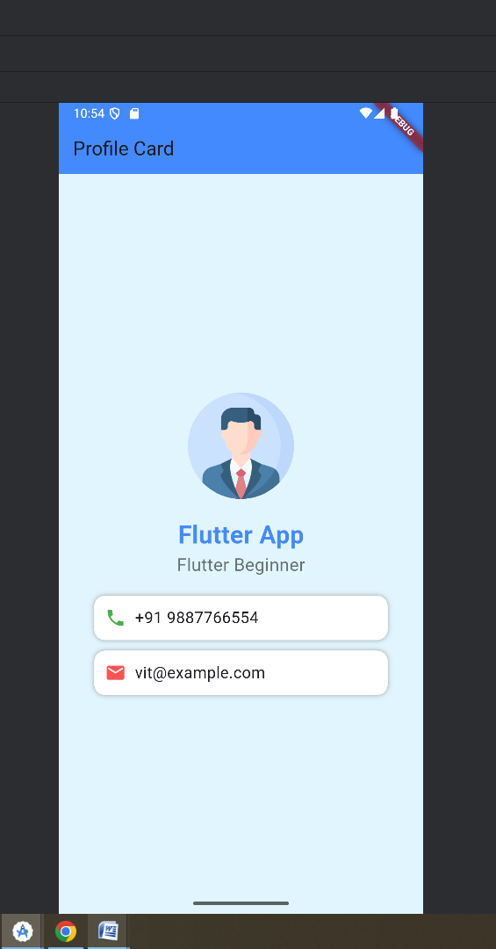

Flutter program that demonstrates different layout structures using the Row, Column, and Stack widgets

import 'package:flutter/material.dart';
void main() {
runApp(const MyApp());
}

class MyApp extends StatelessWidget {
const MyApp({super.key});

@override
Widget build(BuildContext context) {
return MaterialApp(
title: 'Row, Column, Stack Demo',
debugShowCheckedModeBanner: false,
home: Scaffold(
appBar: AppBar(
title: Text('Layout Widgets Demo'),
backgroundColor: Colors.blueAccent,
),
body: SingleChildScrollView(
child: Padding(
padding: const EdgeInsets.all(16),
child: Column(
crossAxisAlignment: CrossAxisAlignment.stretch,
children: [
Text(
'Row Layout',
style: TextStyle(fontSize: 20, fontWeight: FontWeight.bold),
),
rowExample(),
SizedBox(height: 20),
Text(
'Column Layout',
style: TextStyle(fontSize: 20, fontWeight: FontWeight.bold), ),
columnExample(),
SizedBox(height: 20),
Text(
'Stack Layout',
style: TextStyle(fontSize: 20, fontWeight: FontWeight.bold),
),
stackExample(),
],
),
),
),
),
);
}

// Row Layout Example
Widget rowExample() {
return Container(
padding: EdgeInsets.all(10),
color: Colors.lightBlue[50],
child: Row(
mainAxisAlignment: MainAxisAlignment.spaceEvenly,
children: [
coloredBox('A', Colors.red),
coloredBox('B', Colors.green),
coloredBox('C', Colors.blue),
],
),
);
}

// Column Layout Example
Widget columnExample() {
return Container(
padding: EdgeInsets.all(10),
color: Colors.lightGreen[50],
child: Column(
mainAxisAlignment: MainAxisAlignment.spaceEvenly,
children: [
coloredBox('1', Colors.purple),
coloredBox('2', Colors.orange),
coloredBox('3', Colors.brown),
],
),
);
}

// Stack Layout Example
Widget stackExample() {
return Container(
width: double.infinity,
height: 200,
color: Colors.amber[50],
child: Stack(
children: [
Positioned(
left: 30,
top: 30,
child: coloredBox('Bottom', Colors.grey),
),
Positioned(
left: 60,
top: 60,
child: coloredBox('Middle', Colors.blue),
),
Positioned(
left: 90,
top: 90,
child: coloredBox('Top', Colors.red),
),
],
),
);
}

// Colored Box Widget (Fixed)
Widget coloredBox(String label, Color color) {
return Container(
width: 70,
height: 70,
alignment: Alignment.center,
decoration: BoxDecoration(
color: color,
borderRadius: BorderRadius.circular(10),
),
child: Text(
label,
style: TextStyle(
color: Colors.white,
fontWeight: FontWeight.bold,
),
),
);
}
}
Output:
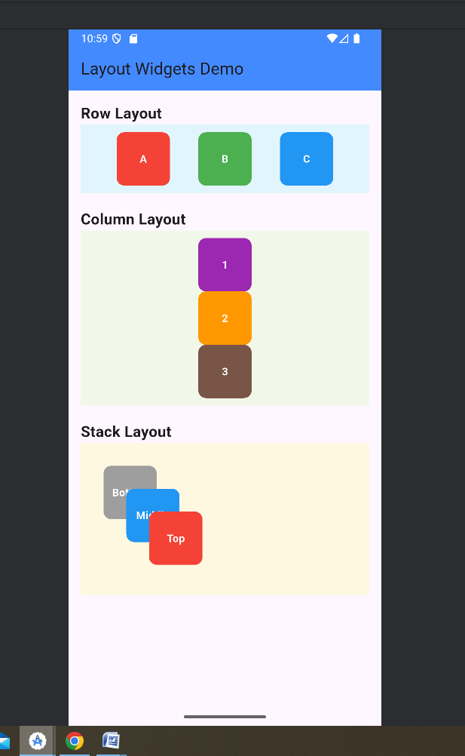

Design a responsive UI that adapts to different screen sizes.
import 'package:flutter/material.dart';
void main() {
runApp(const ResponsiveOrientationApp());
}

class ResponsiveOrientationApp extends StatelessWidget {
const ResponsiveOrientationApp({super.key});

@override
Widget build(BuildContext context) {
return const MaterialApp(
debugShowCheckedModeBanner: false,
home: OrientationHomePage(),
);
}
}

class OrientationHomePage extends StatelessWidget {
const OrientationHomePage({super.key});

@override
Widget build(BuildContext context) {
return Scaffold(
appBar: AppBar(
title: const Text('Responsive UI - Orientation'),
backgroundColor: Colors.teal,
),
body: OrientationBuilder(
builder: (context, orientation) {
if (orientation == Orientation.portrait) {
return portraitLayout();
} else {
return landscapeLayout();
}
},
),
);
}

Widget portraitLayout() {
return Column(
children: [
Expanded(
child: Container(
margin: const EdgeInsets.all(12),
color: Colors.deepPurple,
alignment: Alignment.center,
child: const Text(
'Portrait Mode',
style: TextStyle(color: Colors.white, fontSize: 24),
),
),
),
Expanded(
child: Container(
margin: const EdgeInsets.all(12),
color: Colors.orange,
alignment: Alignment.center,
child: const Text(
'Bottom Panel',
style: TextStyle(color: Colors.white, fontSize: 24),
),
),
),
],
);
}

Widget landscapeLayout() {
return Row(
children: [
Expanded(
child: Container(
margin: const EdgeInsets.all(12),
color: Colors.deepPurple,
alignment: Alignment.center,
child: const Text(
'Landscape Mode',
style: TextStyle(color: Colors.white, fontSize: 26),
),
),
),
Expanded(
child: Container(
margin: const EdgeInsets.all(12),
color: Colors.orange,
alignment: Alignment.center,
child: const Text(
'Right Panel',
style: TextStyle(color: Colors.white, fontSize: 26),
),
),
),
],
);
}
}

Output:
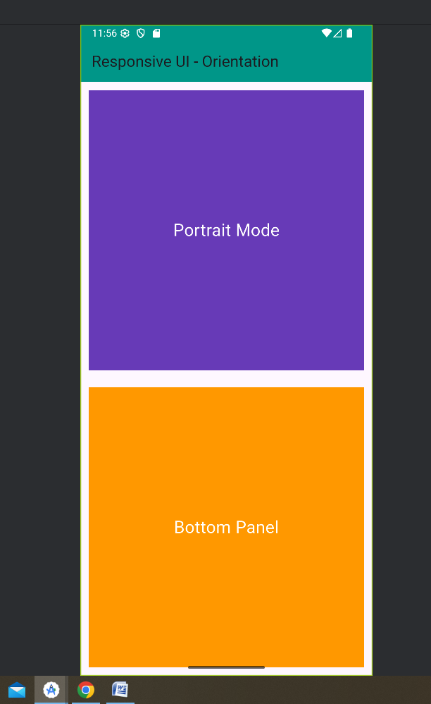
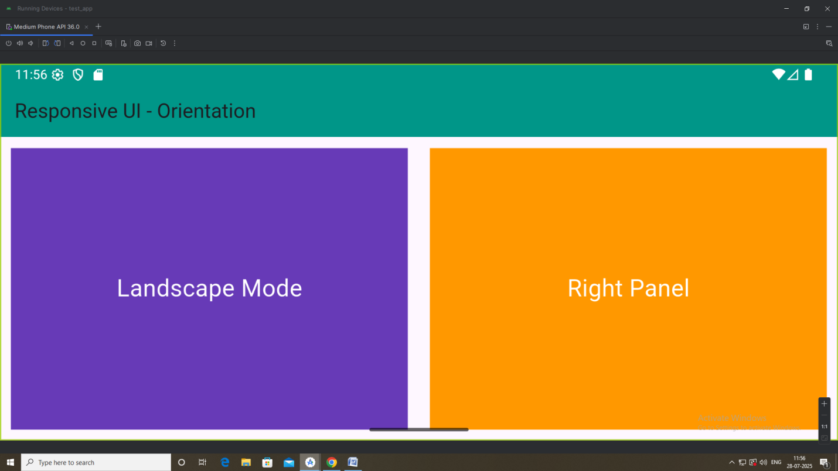

Implement Media queries and breakpoints for responsiveness.

import 'package:flutter/material.dart';
void main() {
runApp(const ResponsiveOrientationApp());
}

class ResponsiveOrientationApp extends StatelessWidget {
const ResponsiveOrientationApp({super.key});

@override
Widget build(BuildContext context) {
return MaterialApp(
title: 'Responsive Breakpoint Demo',
debugShowCheckedModeBanner: false,
home: ResponsiveLayout(),
);
}
}

class ResponsiveLayout extends StatelessWidget {
@override
Widget build(BuildContext context) {
// 📏 Get screen width using MediaQuery
double screenWidth = MediaQuery.of(context).size.width;

// 🧠 Define breakpoints
if (screenWidth < 600) {
return MobileView();
} else if (screenWidth >= 600 && screenWidth < 1024) {
return TabletView();
} else {
return DesktopView();
}
}
}

class MobileView extends StatelessWidget {
@override
Widget build(BuildContext context) {
return Scaffold(
appBar: AppBar(title: Text('Mobile View'), backgroundColor: Colors.deepPurple),
body: Column(
children: [
Expanded(
child: Container(
color: Colors.pink,
child: Center(child: Text("Top Content", style: TextStyle(color: Colors.white, fontSize: 20))),
),
),
Expanded(
child: Container(
color: Colors.indigo,
child: Center(child: Text("Bottom Content", style: TextStyle(color: Colors.white, fontSize: 20))),
),
),
],
),
);
}
}

class TabletView extends StatelessWidget {
@override
Widget build(BuildContext context) {
return Scaffold(
appBar: AppBar(title: Text('Tablet View'), backgroundColor: Colors.green),
body: Row(
children: [
Expanded(
child: Container(
color: Colors.teal,
child: Center(child: Text("Left Panel", style: TextStyle(color: Colors.white, fontSize: 22))),
),
),
Expanded(
child: Container(
color: Colors.blueGrey,
child: Center(child: Text("Right Panel", style: TextStyle(color: Colors.white, fontSize: 22))),
),
),
],
),
);
}
}

class DesktopView extends StatelessWidget {
@override
Widget build(BuildContext context) {
return Scaffold(
appBar: AppBar(
title: Text('Desktop View'), backgroundColor: Colors.orange),
body: Row(
children: [
Expanded(
flex: 1,
child: Container(
color: Colors.blue[800],
child: Center(child: Text("Sidebar",
style: TextStyle(color: Colors.white, fontSize: 24))),
),
),
Expanded(
flex: 3,
child: Container(
color: Colors.amber[800],
child: Center(child: Text("Main Content",
style: TextStyle(color: Colors.black, fontSize: 24))),
),
),
],
),
);
}
}

Output:
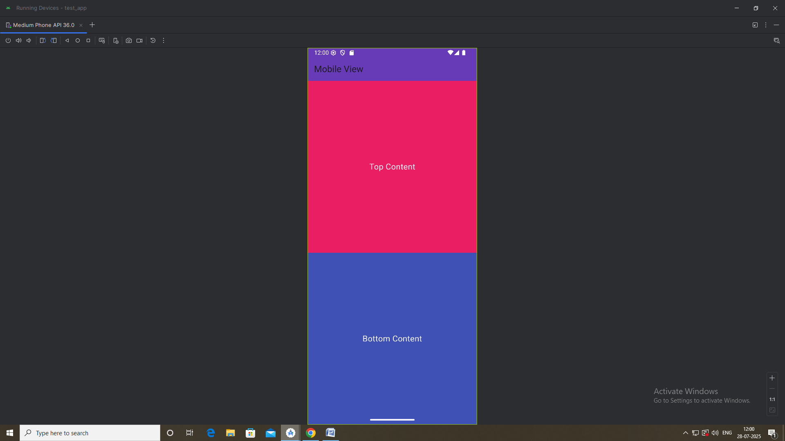

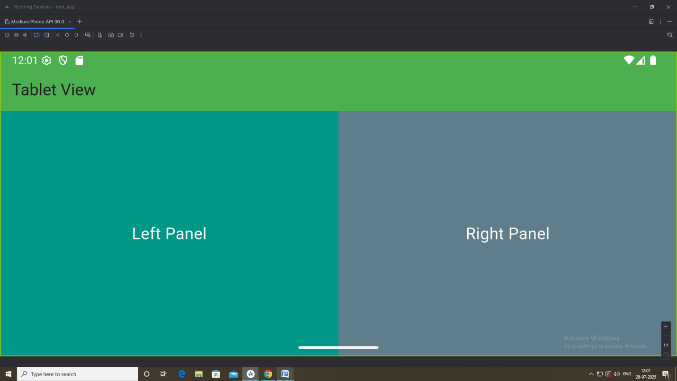

Set up navigation between different screens using Navigator

import 'package:flutter/material.dart';
void main() {
runApp(const MyApp());
}

class MyApp extends StatelessWidget {
const MyApp({super.key});

@override
Widget build(BuildContext context) {
return MaterialApp(
title: 'Navigator Example',
theme: ThemeData(primarySwatch: Colors.teal),
home: const HomeScreen(),
debugShowCheckedModeBanner: false,
);
}
}

class HomeScreen extends StatelessWidget {
const HomeScreen({super.key});

@override
Widget build(BuildContext context) {
return Scaffold(
appBar: AppBar(title: const Text('Home Screen')),
body: Center(
child: ElevatedButton(
style: ElevatedButton.styleFrom(backgroundColor: Colors.teal),
child: const Text('Go to Second Screen'),
onPressed: () {
Navigator.push(
context,
MaterialPageRoute(builder: (context) => const SecondScreen()),
);
},
),
),
);
}
}

class SecondScreen extends StatelessWidget {
const SecondScreen({super.key});

@override
Widget build(BuildContext context) {
return Scaffold(
appBar: AppBar(title: const Text('Second Screen')),
body: Center(
child: ElevatedButton(
style: ElevatedButton.styleFrom(backgroundColor: Colors.teal),
child: const Text('Go Back'),
onPressed: () {
Navigator.pop(context); // Go back to HomeScreen
},
),
),
);
}
}

Output:
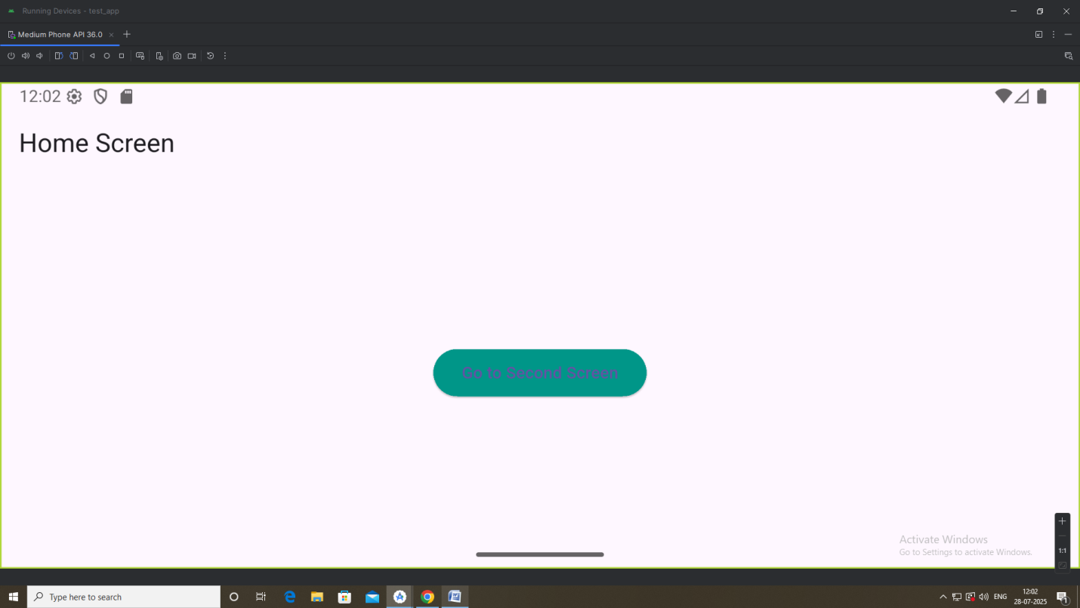
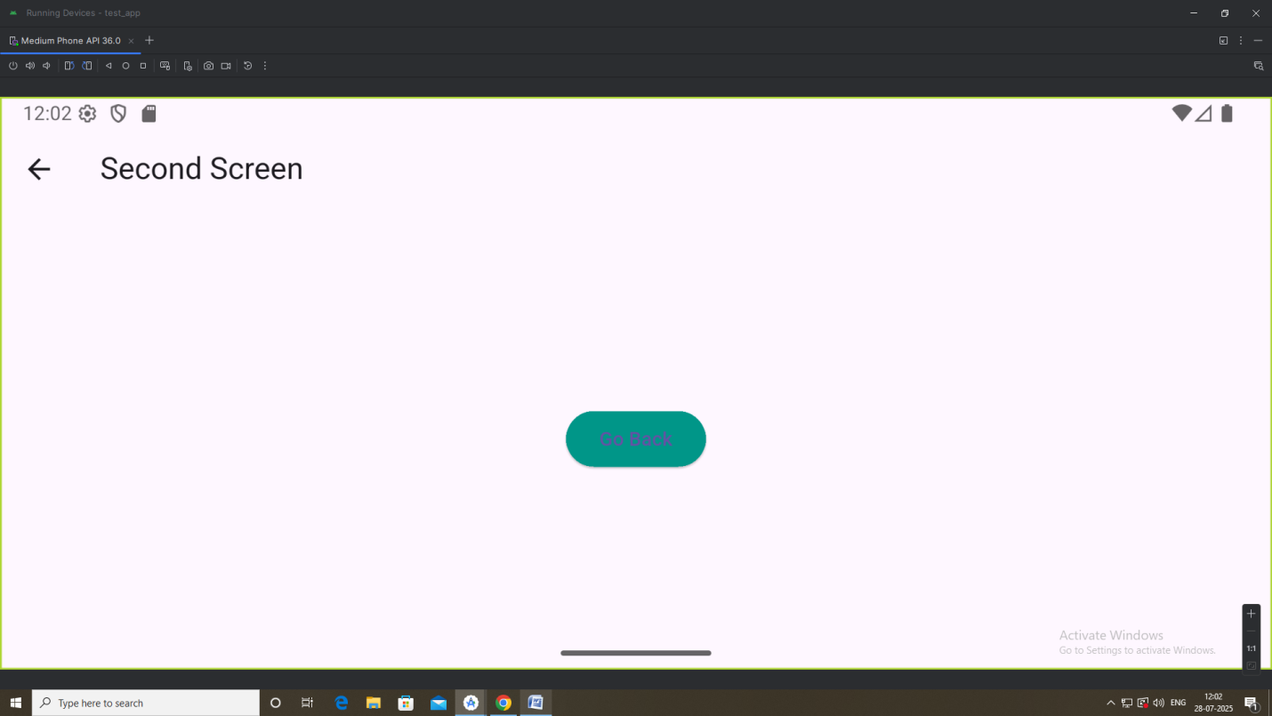

Implement navigation with named routes
import 'package:flutter/material.dart';
void main() =>
runApp(MyApp());
class MyApp extends StatelessWidget {
@override
Widget build(BuildContext context) {
return MaterialApp(
title: 'Named Route Demo',
theme: ThemeData(primarySwatch: Colors.blue),
initialRoute: '/',
routes: {
'/': (context) => FirstScreen(),
'/second': (context) => SecondScreen(),
},
);
}
}

class FirstScreen extends StatelessWidget {
@override
Widget build(BuildContext context) {
return Scaffold(
appBar: AppBar(title: Text("Home")),
body: Center(
child: ElevatedButton(
child: Text("Go to Second Screen"),
onPressed: () {
Navigator.pushNamed(context, '/second');
},
),
),
);
}
}

class SecondScreen extends StatelessWidget {
@override
Widget build(BuildContext context) {
return Scaffold(
appBar: AppBar(title: Text("Second Screen")),
body: Center(
child: Text(
'Welcome to Second Screen!',
style: TextStyle(fontSize: 24, color: Colors.black),
),
),
);
}
}

Output:
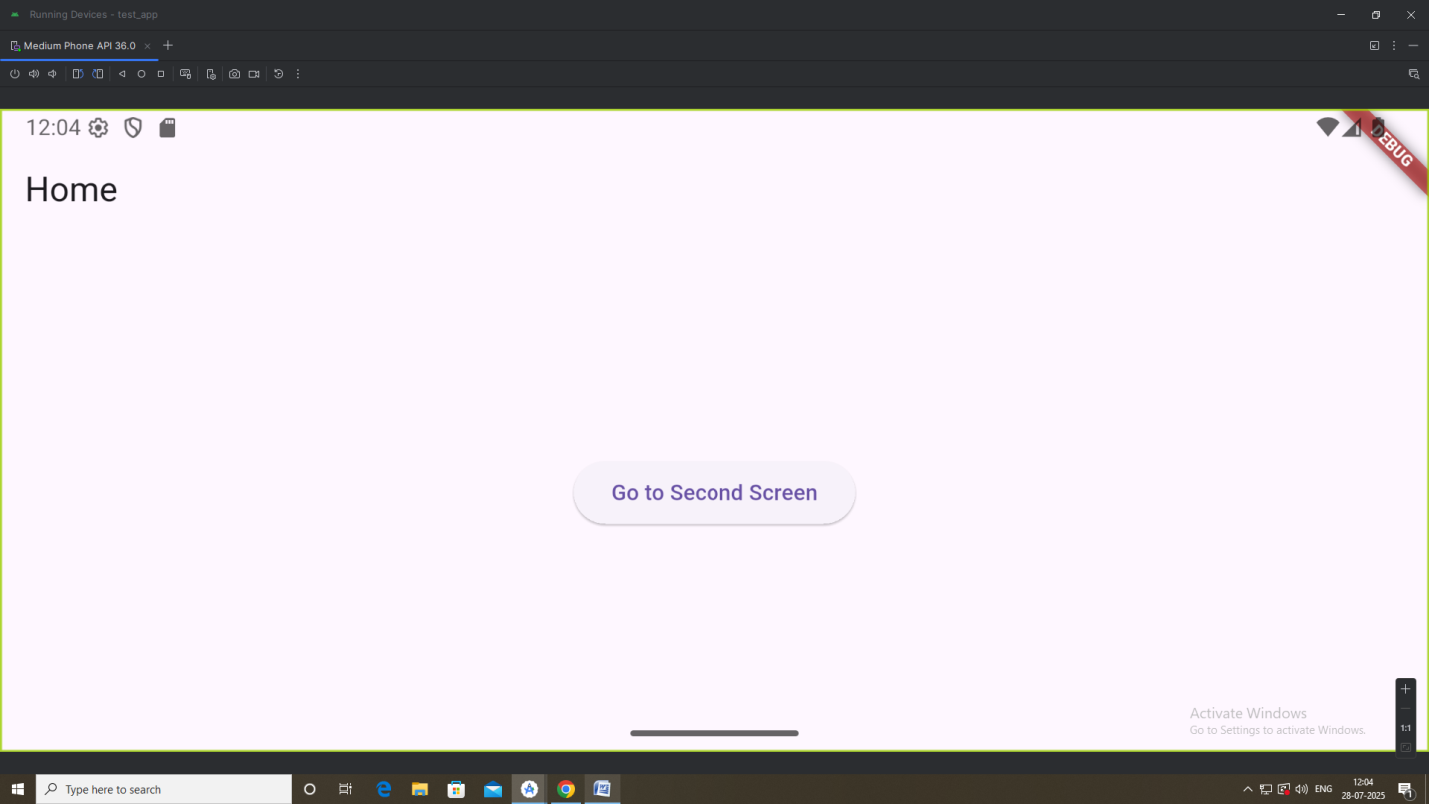
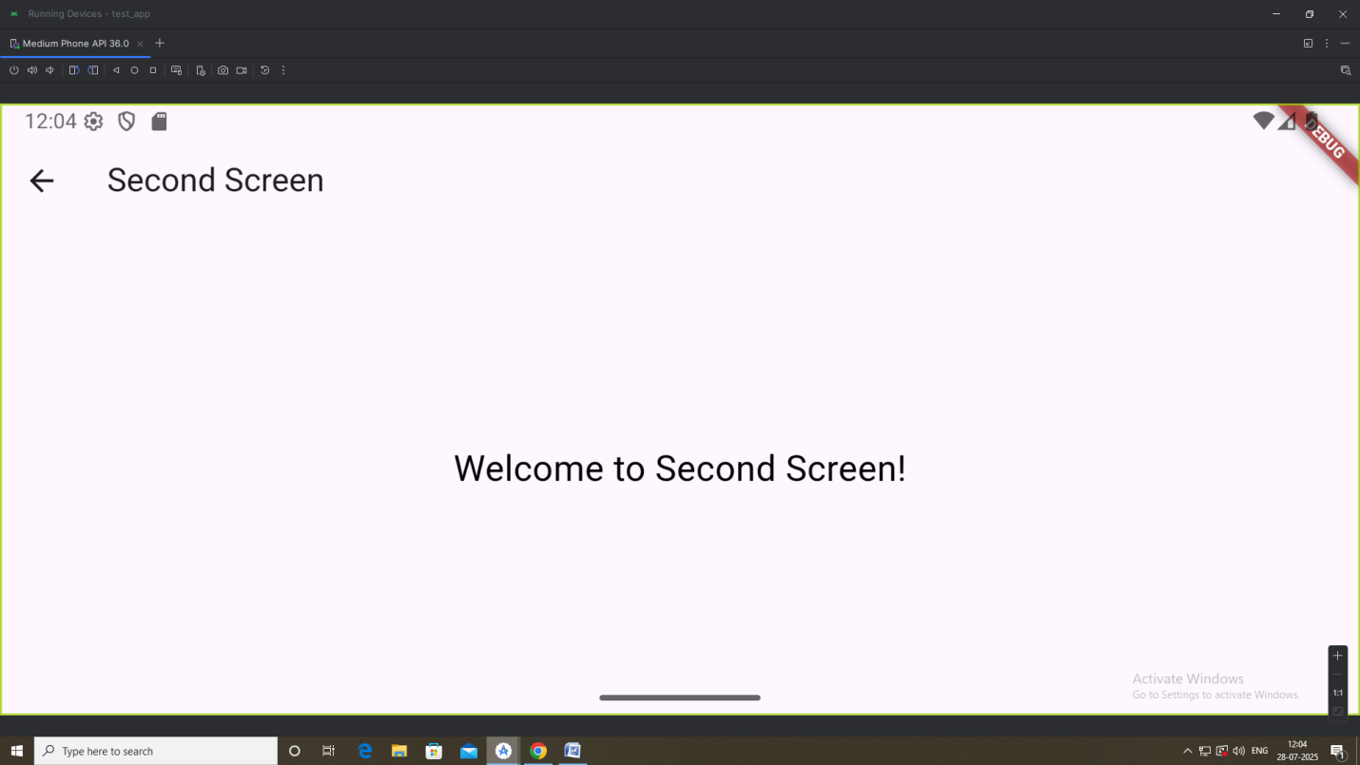
Learn about stateful and stateless widgets
import 'package:flutter/material.dart';

void main() {
runApp(MyApp());
}

// Root widget using StatelessWidget
class MyApp extends StatelessWidget {
@override
Widget build(BuildContext context) {
return MaterialApp(
title: 'Stateless vs Stateful',
theme: ThemeData(primarySwatch: Colors.blue),
home: HomePage(),
);
}
}

// HomePage is also Stateless, static screen
class HomePage extends StatelessWidget {
@override
Widget build(BuildContext context) {
return Scaffold(
appBar: AppBar(title: Text('Stateless vs Stateful')),
body: Column(
mainAxisAlignment: MainAxisAlignment.center,
children: [
Center(child: StaticTextWidget()), // Stateless
SizedBox(height: 40),
Center(child: CounterWidget()), // Stateful
],
),
);
}
}

// ✅ Stateless Widget (shows static text)
class StaticTextWidget extends StatelessWidget {
@override
Widget build(BuildContext context) {
print("StaticTextWidget rebuilt");
return Text(
'I am a Stateless Widget!',
style: TextStyle(fontSize: 20, color: Colors.black),
);
}
}

// ✅ Stateful Widget (has a counter and updates state)
class CounterWidget extends StatefulWidget {
@override
_CounterWidgetState createState() => _CounterWidgetState();
}

class _CounterWidgetState extends State<CounterWidget> {
int _count = 0;

void _incrementCounter() {
setState(() {
_count++;
});
}

@override
Widget build(BuildContext context) {
print("CounterWidget rebuilt with count: $_count");
return Column(
children: [
Text(
'Counter: $_count',
style: TextStyle(fontSize: 24, color: Colors.blue),
),
SizedBox(height: 10),
ElevatedButton(
onPressed: _incrementCounter,
child: Text('Increment'),
),
],
);
}
}
Output:
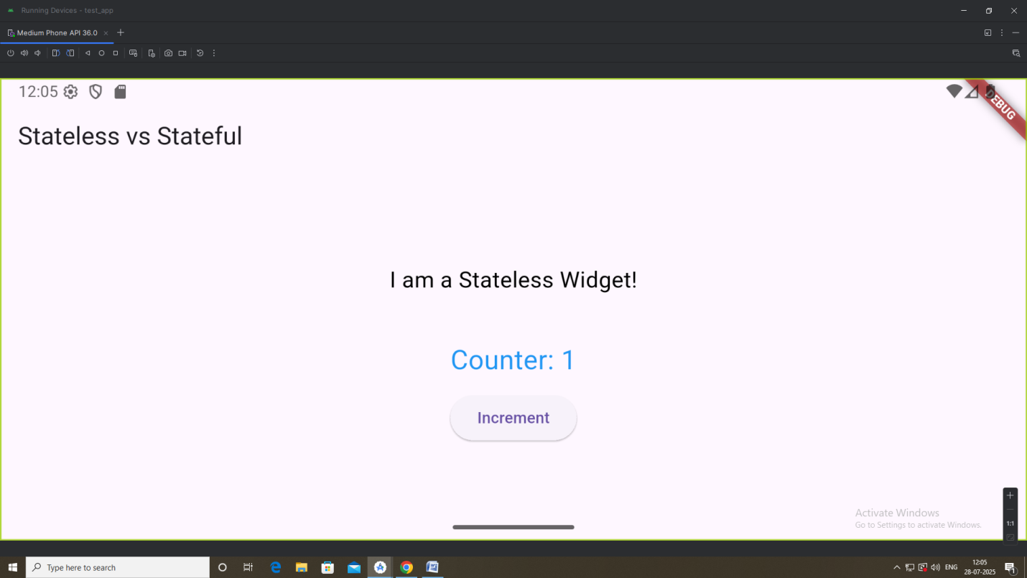
Implement state management using setState and Provider
Pubspec.yaml
dependencies:
flutter:
sdk: flutter
provider: ^6.1.1 # ✅ Add provider here
# The following adds the Cupertino Icons font to your application.
# Use with the CupertinoIcons class for iOS style icons.
cupertino_icons: ^1.0.8
dev_dependencies:
flutter_test:
sdk: flutter

Main.dart
import 'package:flutter/material.dart';
import 'package:provider/provider.dart';
import 'counter_provider.dart';

void main() {
runApp(
ChangeNotifierProvider(
create: (_) => CounterProvider(),
child: MyApp(),
),
);
}

class MyApp extends StatelessWidget {
@override
Widget build(BuildContext context) {
return MaterialApp(
title: 'State Management Demo',
theme: ThemeData(primarySwatch: Colors.blue),
home: HomeScreen(),
);
}
}

class HomeScreen extends StatelessWidget {
@override
Widget build(BuildContext context) {
final providerCounter = Provider.of<CounterProvider>(context);

return Scaffold(
appBar: AppBar(title: Text('State Management')),
body: Padding(
padding: const EdgeInsets.all(20.0),
child: Column(
children: [
// ✅ Using setState
SetStateCounter(),

Divider(thickness: 2, height: 40),

// ✅ Using Provider
Text(
'Provider Counter: ${providerCounter.count}',
style: TextStyle(fontSize: 24, color: Colors.green),
),
ElevatedButton(
onPressed: () => providerCounter.increment(),
child: Text("Increment with Provider"),
),
],
),
),
);
}
}

// ✅ Counter using setState
class SetStateCounter extends StatefulWidget {
@override
_SetStateCounterState createState() => _SetStateCounterState();
}

class _SetStateCounterState extends State<SetStateCounter> {
int count = 0;

@override
Widget build(BuildContext context) {
return Column(
children: [
Text(
'setState Counter: $count',
style: TextStyle(fontSize: 24, color: Colors.blue),
),
ElevatedButton(
onPressed: () {
setState(() {
count++;
});
},
child: Text("Increment with setState"),
),
],
);
}
}
counter_provider.dart
import 'package:flutter/material.dart';
class CounterProvider extends ChangeNotifier {
int _count = 0;

int get count => _count;

void increment() {
_count++;
notifyListeners(); // triggers UI update
}
}
Output:
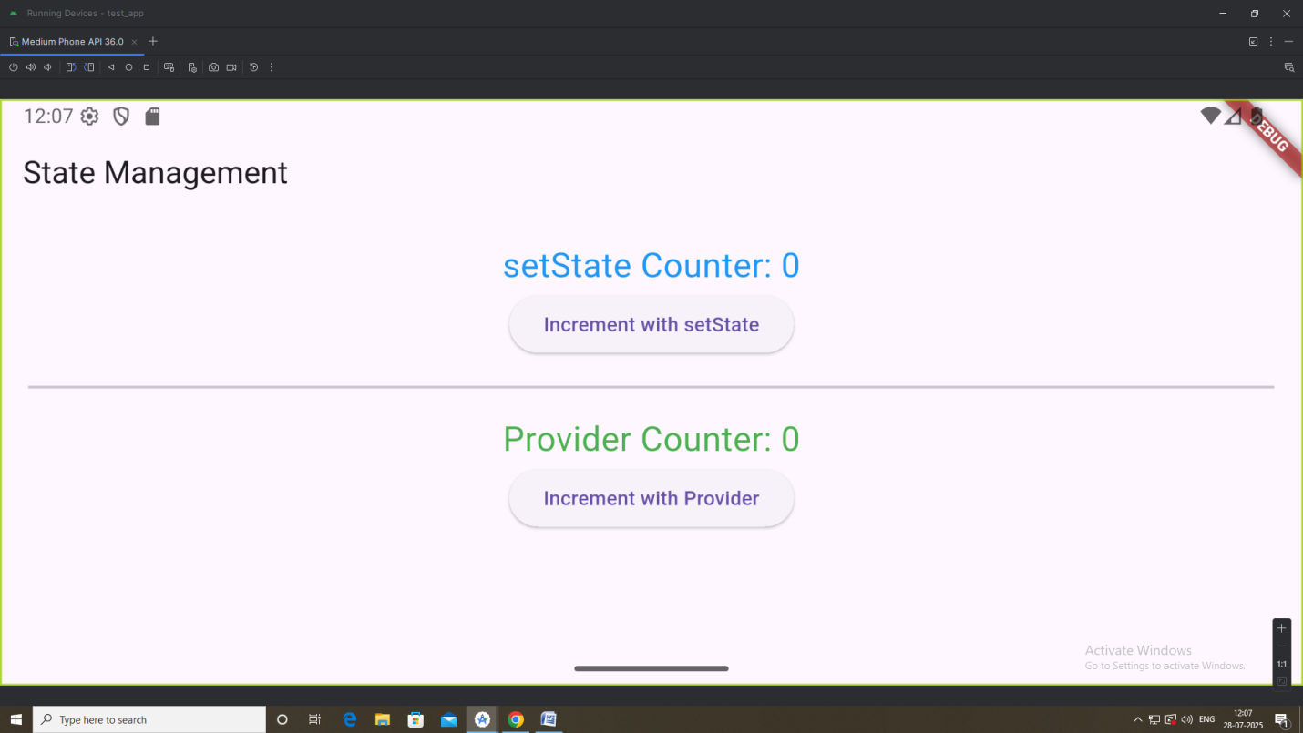
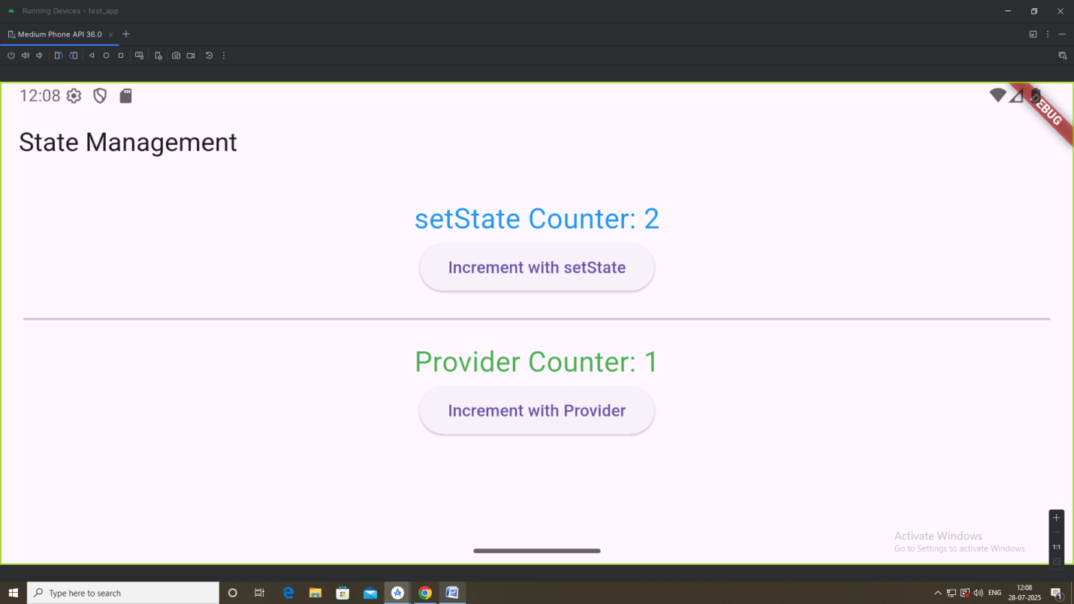
Create custom widgets for specific UI elements
lib/
├── main.dart
├── widgets/
│ ├── custom_title.dart
│ ├── custom_button.dart
│ └── custom_card.dart

main.dart
import 'package:flutter/material.dart';
import 'widgets/custom_title.dart';
import 'widgets/custom_button.dart';
import 'widgets/custom_card.dart';

void main() {
runApp(MyApp());
}

class MyApp extends StatelessWidget {
@override
Widget build(BuildContext context) {
return MaterialApp(
title: 'Custom Widget Demo',
home: HomePage(), // Use a separate widget for the homepage
);
}
}

class HomePage extends StatelessWidget {
@override
Widget build(BuildContext context) {
return Scaffold(
appBar: AppBar(title: Text('Custom Widgets')),
body: Builder(
builder: (context) => Padding(
padding: const EdgeInsets.all(16.0),
child: Column(
crossAxisAlignment: CrossAxisAlignment.stretch,
children: [
CustomTitle(text: 'Welcome to My App'),
SizedBox(height: 20),
CustomCard(content: 'This is a custom card widget.'),
SizedBox(height: 20),
CustomButton(
text: 'Click Me',
onPressed: () {
// FIX: Use context from Builder
ScaffoldMessenger.of(context).showSnackBar(
SnackBar(content: Text('Button Pressed!')),
);
},
),
],
),
),
),
);
}
}

custom_title.dart
import 'package:flutter/material.dart';
class CustomTitle extends StatelessWidget {
final String text;
const CustomTitle({required this.text});

@override
Widget build(BuildContext context) {
return Text(
text,
style: TextStyle(fontSize: 26, fontWeight: FontWeight.bold),
);
}
}

custom_button.dart
import 'package:flutter/material.dart';
class CustomButton extends StatelessWidget {
final String text;
final VoidCallback onPressed;
const CustomButton({required this.text, required this.onPressed});
@override
Widget build(BuildContext context) {
return ElevatedButton(
onPressed: onPressed,
child: Text(text),
style: ElevatedButton.styleFrom(
padding: EdgeInsets.symmetric(vertical: 16),
textStyle: TextStyle(fontSize: 18),
),
);
}
}

custom_card.dart
import 'package:flutter/material.dart';
class CustomCard extends StatelessWidget {
final String content;

const CustomCard({required this.content});
@override
Widget build(BuildContext context) {
return Card(
elevation: 4,
shape: RoundedRectangleBorder(borderRadius: BorderRadius.circular(10)),
child: Padding(
padding: const EdgeInsets.all(16.0),
child: Text(
content,
style: TextStyle(fontSize: 16),
),
),
);
}
}

Output:
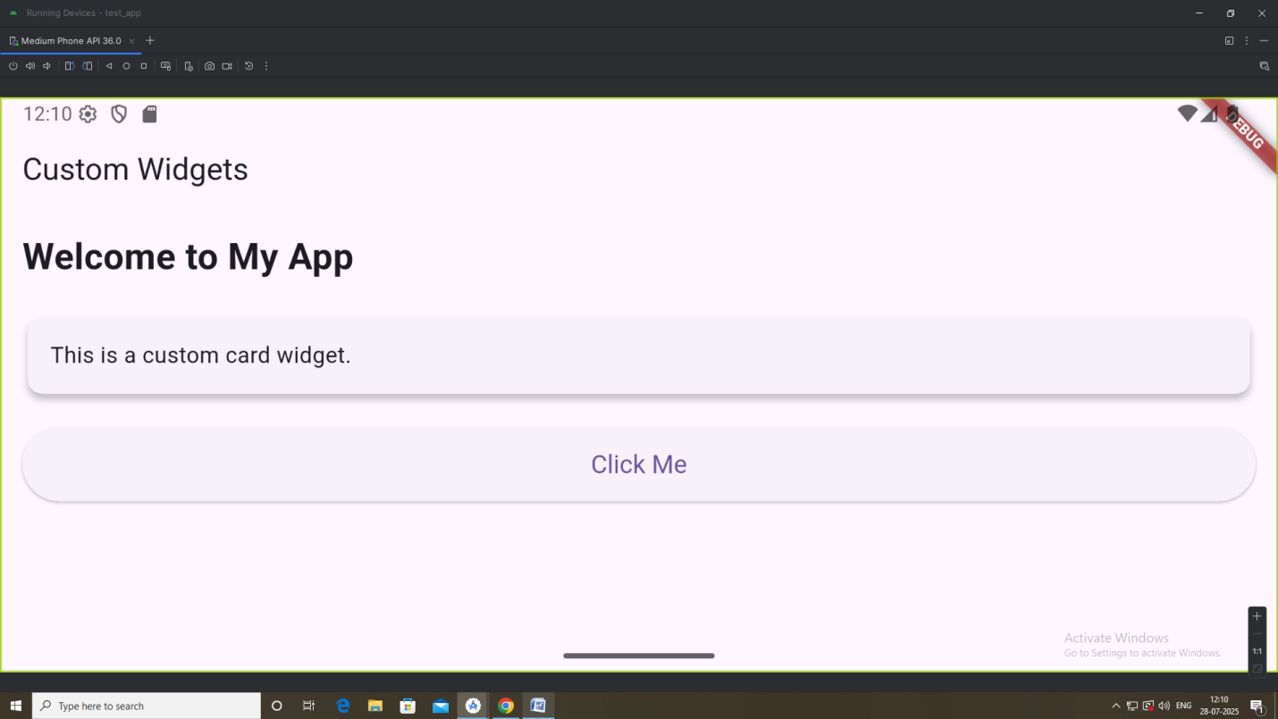
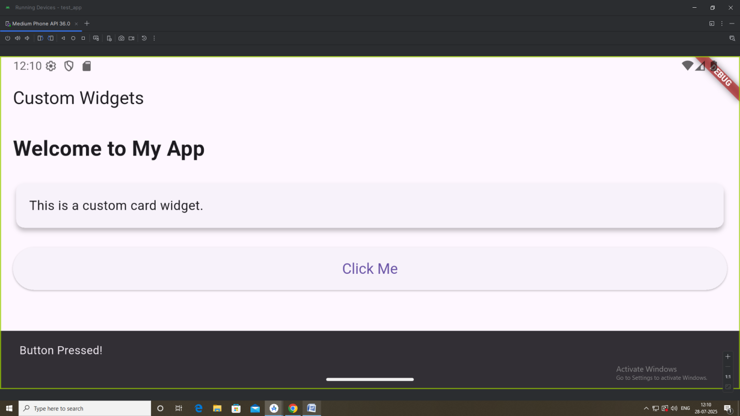

Apply Styling using themes and custom styles
/lib
┣ main.dart
┣ home_page.dart
┗ /widgets
┣ custom_title.dart
┣ custom_card.dart
┗ custom_button.dart
main.dart
import 'package:flutter/material.dart';
import 'home_page.dart';

void main() {
runApp(MyApp());
}

class MyApp extends StatelessWidget {
const MyApp({super.key});

@override
Widget build(BuildContext context) {
return MaterialApp(
title: 'Themed App',
theme: ThemeData(
primarySwatch: Colors.deepPurple,
scaffoldBackgroundColor: Colors.deepPurple[50],
textTheme: const TextTheme(
headlineMedium: TextStyle(fontSize: 24, fontWeight: FontWeight.bold),
bodyLarge: TextStyle(fontSize: 18),
),
elevatedButtonTheme: ElevatedButtonThemeData(
style: ElevatedButton.styleFrom(
backgroundColor: Colors.deepPurple,
foregroundColor: Colors.white,
padding: EdgeInsets.symmetric(horizontal: 24, vertical: 12),
shape: RoundedRectangleBorder(
borderRadius: BorderRadius.circular(12),
),
),
),
),
home: const HomePage(),
);
}
}

home_page.dart
import 'package:flutter/material.dart';
import 'widgets/custom_card.dart';
import 'widgets/custom_title.dart';
import 'widgets/custom_button.dart';

class HomePage extends StatelessWidget {
const HomePage({super.key});

@override
Widget build(BuildContext context) {
return Scaffold(
appBar: AppBar(title: const Text('Home Page')),
body: Padding(
padding: const EdgeInsets.all(16.0),
child: Column(
crossAxisAlignment: CrossAxisAlignment.start,
children: [
const CustomTitle(text: 'Welcome to Themed App'),
const SizedBox(height: 20),
const CustomCard(
title: 'Custom Card Title',
content: 'This card is styled using theme settings and custom widgets.',
),
const SizedBox(height: 20),
CustomButton(
text: 'Click Me',
onPressed: () {
ScaffoldMessenger.of(context).showSnackBar(
const SnackBar(content: Text('Button Pressed')),
);
},
),
],
),
),
);
}
}
custom_title.dart
import 'package:flutter/material.dart';
class CustomTitle extends StatelessWidget {
final String text;
const CustomTitle({super.key, required this.text});

@override
Widget build(BuildContext context) {
return Text(
text,
style: Theme.of(context).textTheme.headlineMedium,
);
}
}
custom_button.dart
import 'package:flutter/material.dart';
class CustomButton extends StatelessWidget {
final String text;
final VoidCallback onPressed;
const CustomButton({
super.key,
required this.text,
required this.onPressed,
});

@override
Widget build(BuildContext context) {
return ElevatedButton(
onPressed: onPressed,
child: Text(text),
);
}
}

custom_card.dart
import 'package:flutter/material.dart';
class CustomCard extends StatelessWidget {
final String title;
final String content;
const CustomCard({
super.key,
required this.title,
required this.content,
});

@override
Widget build(BuildContext context) {
return Card(
color: Colors.white,
elevation: 4,
margin: const EdgeInsets.all(10),
shape: RoundedRectangleBorder(
borderRadius: BorderRadius.circular(12),
),
child: Padding(
padding: const EdgeInsets.all(16.0),
child: Column(
crossAxisAlignment: CrossAxisAlignment.start,
children: [
Text(title, style: Theme.of(context).textTheme.headlineMedium),
const SizedBox(height: 10),
Text(content, style: Theme.of(context).textTheme.bodyLarge),
],
),
),
);
}
}

Output:
